**Areas for improvement:**

Use clearer and clearer language to reinforce the image.

Improve consistency by providing smooth transitions between details.

**Pre-writing:**

1. What are you trying to explain?

I will describe Central Park in New York City.

2. Why did you choose this location?

Central Park is a place I know well and have visited many times. It represents a peaceful escape in the middle of the busy city and offers a variety of sensory experiences. The separation of nature and city life provides rich material for vivid and detailed descriptions.

3. What specific impact do you want to make?

I want to create an impression of tranquility and beauty, showing the harmony between nature and the urban environment.

4. How will you organize your work?

In the work, I will describe different parts of the park, as shown in the picture, from right to left. This spatial arrangement will help create a logical flow of information.

5. Fill in the chart below with as much information as possible.

appearance

|  |  |  |  |  |
| --- | --- | --- | --- | --- |
| SIGHT | SOUND | TASTE | TOUCH | SMELL |
| People standing and talking on the right. | People laugh and chat. | Flavored drinks or snacks (eg ice cream, lemonade) brought to the park to enjoy. | Soft, cool grass underfoot. | It smells like freshly cut grass. |
| People sit by the fire. | The leaves are rustling in the wind. |  | The warmth of the sun on the skin. | The smell of flowers and trees. |
| The wide green grass stretches to the sky. | The sounds around the park, including the distant city traffic. |  | The breeze blows against your face. | The smell of food from a nearby vendor. |
| People lying on blankets in the sun. | He gets occasional shouts from people playing the game. |  | The rough construction of a picnic blanket. | A hint of city air mixed with the scent of nature. |
| A dense tree line creates a natural barrier. | The birds are chirping in the trees. |  | Flat garden bench. |  |

**Selected location:**

Central Park, New York City.

**Picture:**

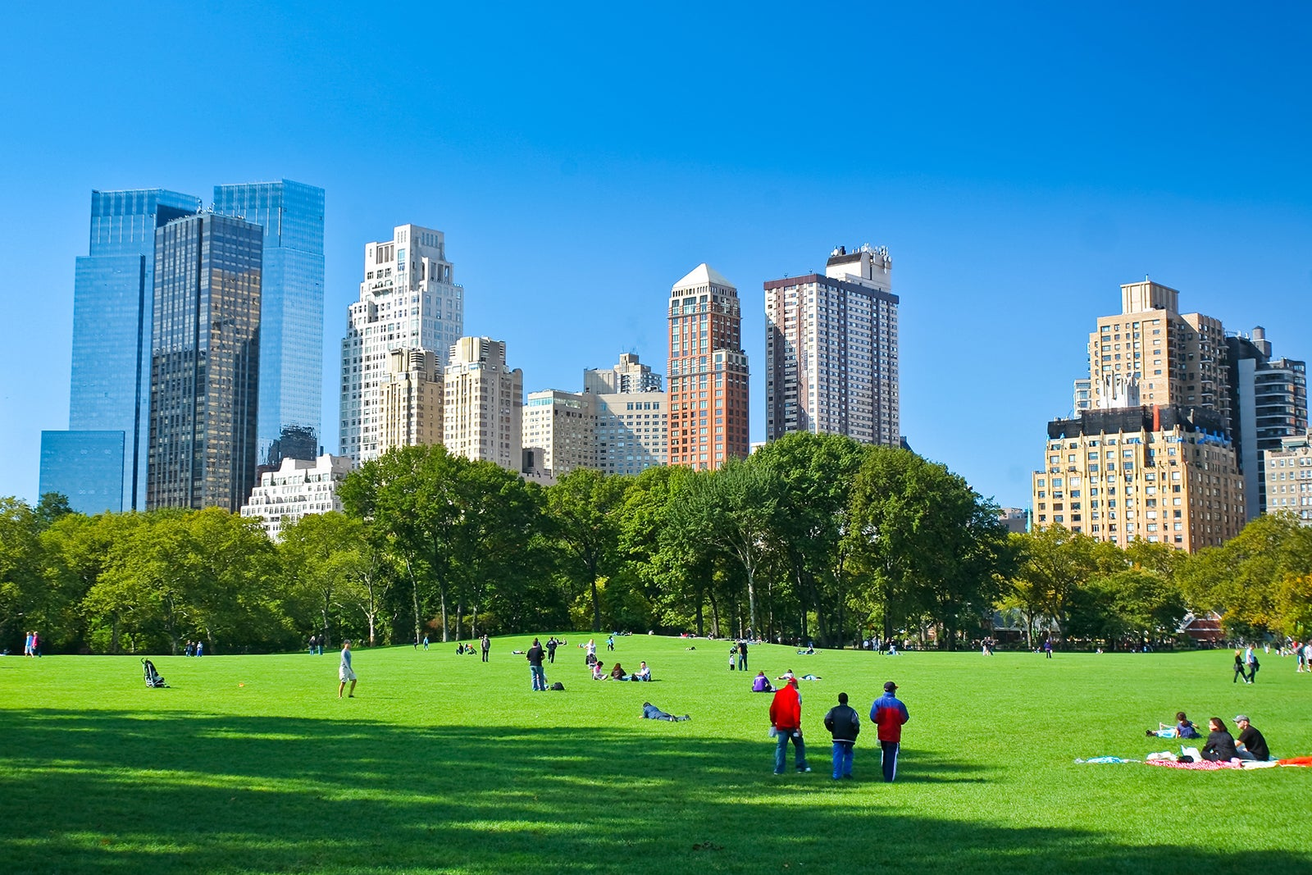

**Image Description:**

The photo shows a sunny day in Central Park, with green lawns, people enjoying the holidays, and tall buildings under a clear blue sky.

**Plans**

**Introduction:**

Central Park is a vibrant oasis in the midst of New York City's bustling urban landscape.

Details:

right:

A group of people in open clothes are standing and talking.

Some people sit by the fire and start their own business.

before:

A wide expanse of green grass stretches to the sky.

Some people lay on blankets and sunbathe.

Then:

A dense tree, its leaves create a natural barrier.

The tall buildings of New York City provide a striking contrast to the lush greenery.

Left:

A small group of friends playing Frisbee or having a picnic.

A poor man enjoys comfort.

The results:

Central Park offers the perfect escape for city dwellers, blending the beauty of nature with the atmosphere of the city.

**First Draft:**

Central Park is a vibrant oasis in the midst of New York City's bustling urban landscape. On the right, a group of people in open clothes chat and talk animatedly, while some people sit by the fire, engaged in their work. Ahead, a wide and green lawn stretches towards the sky, lined with several people lying on blankets basking in the warm embrace of the sun. Behind them, a thicket of trees provided a natural barrier, their leaves rustling in the breeze. The skyscrapers of New York City rise majestically in the background and provide a stark contrast to the greenery. On the left, a small group of friends are playing frisbee or having a picnic, their laughter mixed with the sounds around the park. The average person relaxes, enjoys comfort and fresh air. Central Park offers a perfect escape for city dwellers who can truly appreciate the harmony between nature and city life, blending with natural beauty and urban vibrancy.

**Polish Draft:**

A Day in Central Park:

Central Park is a vibrant oasis in the midst of New York City's bustling urban landscape. On the right, a group of people in open clothes chat and talk animatedly, while some people sit by the fire, engaged in their work. Ahead, a wide and green lawn stretches towards the sky, lined with several people lying on blankets basking in the warm embrace of the sun. Behind him, a grove of trees provided a natural barrier, their leaves rustling in the breeze. The skyscrapers of New York City rise majestically in the background and provide a stark contrast to the greenery. On the left, a small group of friends are playing frisbee or having a picnic, their laughter mixed with the sounds around the park. The average person relaxes, enjoys comfort and fresh air. Central Park offers a perfect escape for city dwellers who can truly appreciate the harmony between nature and city life, blending with natural beauty and urban vibrancy. The sweet smell of freshly cut grass and the smell of distant city traffic blend seamlessly, creating a refreshing and peaceful atmosphere.

Helen Shembo  
Brewer Alexandra  
WRI 0105  
27 May 2024